[CEN 323 ] Computer Organization & Assembly Language
Lab 10 Journal

Name : Fatima Asad
Enrollment Number: 01-135232-020

Lab Deliverables (submission guideline)

Create a folder named after your enrollment number and add the following files:
  - Create a folder named YourRollNumber_Lab10 containing:
- .asm files of the Three Practice tasks.
- .asm files of the Two Unseen tasks.
- Add full screen screenshots of the code and output in this word file.
  - Zip the Folder and upload it to LMS.

Lab Task

Task 1:
Code (TEXT):
include 'emu8086.inc'
org 100h

sumMacro MACRO p1,p2,p3,p4,p5
LOCAL print_one, print_two, finish

mov al,p1
add al,p2
add al,p3
add al,p4
add al,p5

mov ah,0
cmp al,9
jg print_two

print_one:
mov dl,al
add dl,48
mov ah,2
int 21h
jmp finish

print_two:
mov cl,10
div cl
mov bh,ah

mov dl,al
add dl,48
mov ah,2
int 21h

mov dl,bh
add dl,48
mov ah,2
int 21h

finish:
ENDM

mov cx,5
mov bl,1

main_loop:
push cx
PRINT "Sum: "

cmp bl,1
je case1
cmp bl,2
je case2
cmp bl,3
je case3
cmp bl,4
je case4
cmp bl,5
je case5

case1:
sumMacro 1,6,3,4,5
jmp after_case

case2:
sumMacro 1,9,3,7,5
jmp after_case

case3:
sumMacro 1,9,8,2,5
jmp after_case

case4:
sumMacro 1,2,3,4,5
jmp after_case

case5:
sumMacro 1,2,8,4,6

after_case:
PRINTN ""
inc bl
pop cx
loop main_loop

mov ah,4ch
int 21h

Screenshot (CODE):
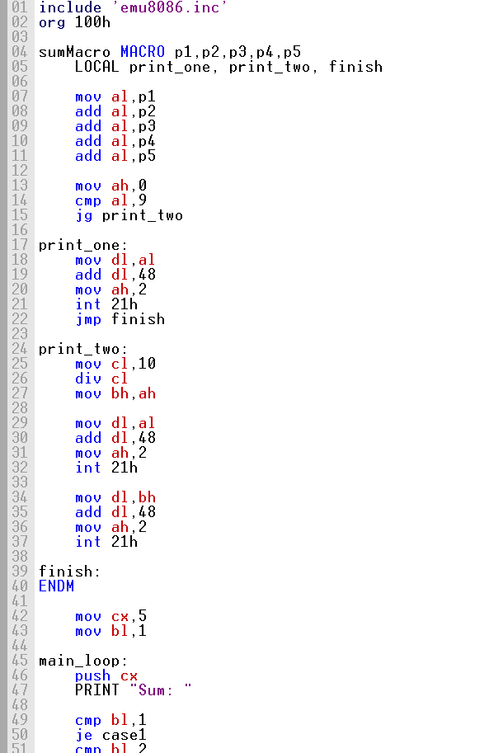

Screenshot (OUTPUT):
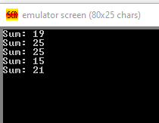

Task 2:
Code (TEXT):
include 'emu8086.inc'
org 100h

product MACRO
LOCAL two_digit, done

mov al, bl
mul cl

mov ah, 0
cmp al, 9
jg two_digit

mov dl, al
add dl, 48
mov ah, 2
int 21h
jmp done

two_digit:
mov ah, 0
mov bl, 10
div bl

mov bh, ah

mov dl, al
add dl, 48
mov ah, 2
int 21h

mov dl, bh
add dl, 48
mov ah, 2
int 21h

done:
ENDM

start:

PRINT "Enter first number: "
mov ah, 1
int 21h
sub al, 48
mov bl, al

PRINTN ""

PRINT "Enter second number: "
mov ah, 1
int 21h
sub al, 48
mov cl, al

PRINTN ""

cmp bl, 0
jne continue_prog

cmp cl, 0
je exit_program

continue_prog:
PRINT "Product: "
product

PRINTN ""
PRINTN ""

jmp start

exit_program:
mov ah, 4Ch
int 21h

Screenshot (CODE):
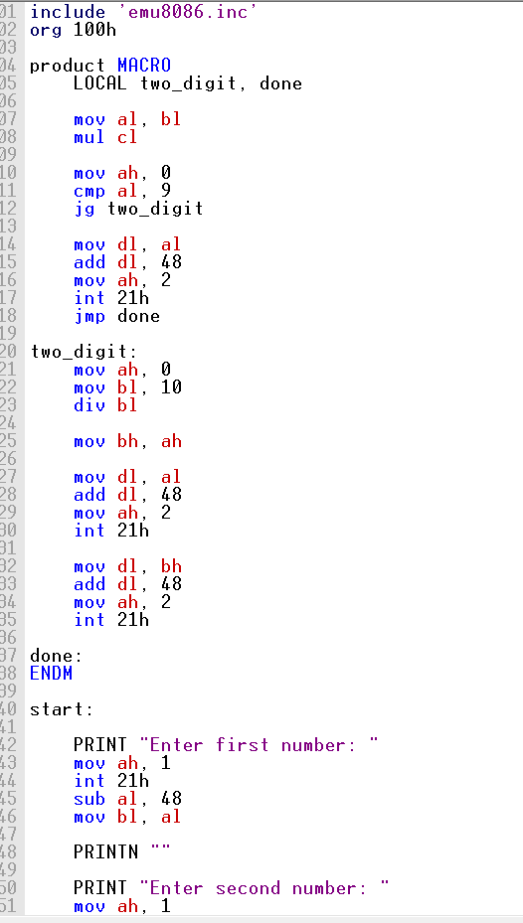

Screenshot (OUTPUT):
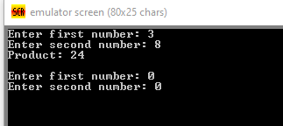

Task 3:
Code (TEXT):
include 'emu8086.inc'
org 100h

printRow MACRO
LOCAL spaces, stars, done

push cx

mov cl, bl
mov ch, 0

cmp cl, 0
je stars

spaces:
PUTC ' '
loop spaces

stars:
mov cl, bh
mov ch, 0

stars_loop:
PUTC '*'
loop stars_loop

PRINTN ""

pop cx
ENDM

mov cx, 7
mov bl, 6
mov bh, 1

main_loop:
push cx

printRow

dec bl
add bh, 2

pop cx
loop main_loop

mov ah, 4Ch
int 21h

Screenshot (CODE):
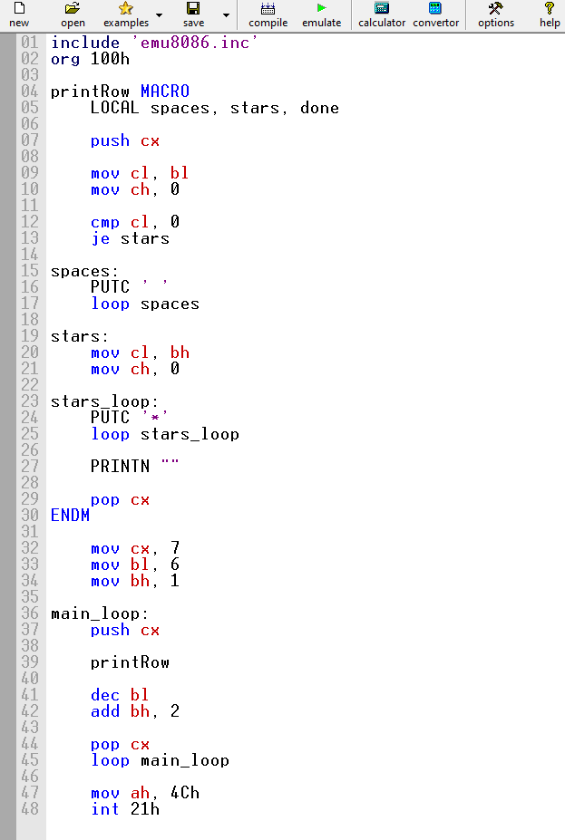

Screenshot (OUTPUT):
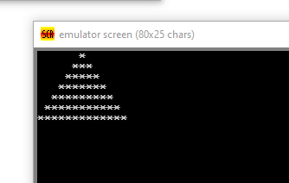

Unseen Task 1:
Make a macro which takes one parameter 'rows' and prints a following pattern with the number of rows given by the user. Invoke the macro in a loop and keep printing the patterns of the given height until user presses enter key.
*
**
***
****

Code (TEXT):
include 'emu8086.inc'
org 100h

printPattern MACRO rows
LOCAL row_loop, col_loop

push cx
push bx

mov bl, 1
mov bh, rows

row_loop:
push bx

mov cl, bl
mov ch, 0

col_loop:
PUTC '*'
loop col_loop

PRINTN ""

pop bx

inc bl
dec bh

cmp bh, 0
jne row_loop

pop bx
pop cx
ENDM

PRINT "Enter number of rows (1-9): "
mov ah, 1
int 21h
sub al, 48
mov dl, al

PRINTN ""

main_loop:
printPattern dl

PRINTN ""

PRINT "Press Enter to stop or any key to print again: "
mov ah, 1
int 21h

PRINTN ""

cmp al, 13
jne main_loop

mov ah, 4Ch
int 21h

Screenshot (CODE):
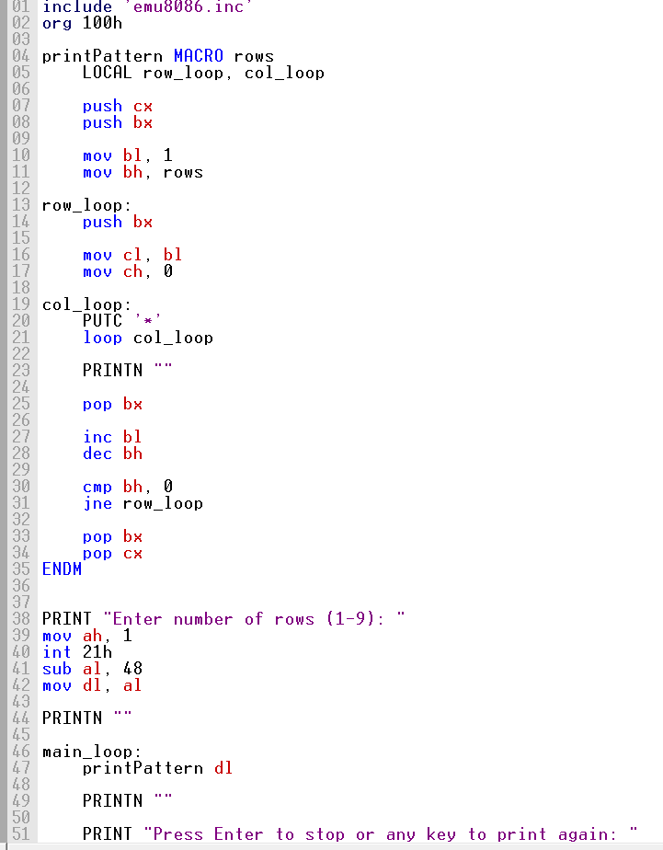

Screenshot (OUTPUT):
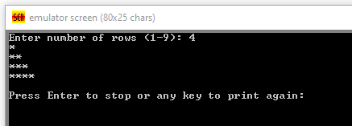

Unseen Task 2:
Make a macro which takes a number as a parameter and handles the output of multiple digits (up to 3 digits).
- If 3 digits are entered the number will automatically be taken as the input.
- User can press the enter key to finish entering the number prematurely.

Code (TEXT):

Screenshot (CODE):

Screenshot (OUTPUT):

